Ryan Napolitano (rn2473)

Professor Nayar

3/21/21

Homework 5, Computer Vision

Written assignment

**Problem 1**: A Lambertian surface is illuminated simultaneously by two distant point sources with equal intensity in the direction s1 and s2. Show that for all normals on the surface that are visible to both sources, illumination can be viewed as coming from a single “effective” direction s3. How is s3 related to s1 and s2? Now, if the two distant sources have unequal intensities I1 and I2, respectively, what is the direction and intensity of the “effective” source?

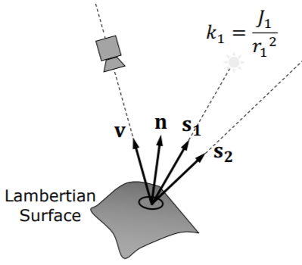

***Figure 1***

On figure 1 you can see two distant point sources lighting a Lambertian surface. Two point sources can be viewed as a single “effective” light source, and it can be expressed using two original light sources as follows:

If $I_{1}= \frac{ρ}{π}k_{1}n∙s_{1}$ and $I_{2}= \frac{ρ}{π}k_{2}n∙s_{2}$ we can write *I3*  as where *I3* is intensity and ***s3*** is direction of the “effective” light source.

**Problem 2**: The reflectance map can be parameterized in various ways. In class we have concentrated on using the gradient (p, q) as a means of specifying surface orientation. In some cases, the Gaussian sphere is more suitable for this purpose. Each point on the Gaussian sphere corresponds to a particular direction, from the center of the sphere to that point. The orientation of a surface patch can be specified by giving the direction of its surface normal. Thus, a given surface orientation can be identified with a particular point on the Gaussian sphere. The reflectance map is merely a means of associating brightness with orientation.

a) What are the contours of constant brightness on the Gaussian sphere in the case of a Lambertian surface illuminated by a point source?

b) Show that there are at most two surface orientations that give rise to a given pair of brightness values when the photometric stereo method is applied to a Lambertian surface. Assume that two different light sources are used.

Answer:

a)



***Figure 2***

Looking at the figure 2, it is obvious that when we have Gaussian sphere which is a Lambertian surface illuminated by a point source, the contours of constant brightness will be circles.

b)



***Figure 3***

Assuming that two different light sources are used, there are at most two surface orientations that give rise to a given pair of brightness values when the photometric stereo method is applied to a Lambertian surface. They can be found in the intersections of the contours of constant brightness formed by each of the light sources individually.